# Wisconsin Word Cloud

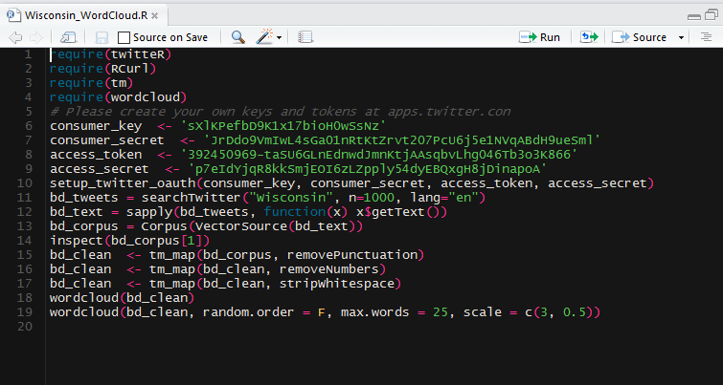

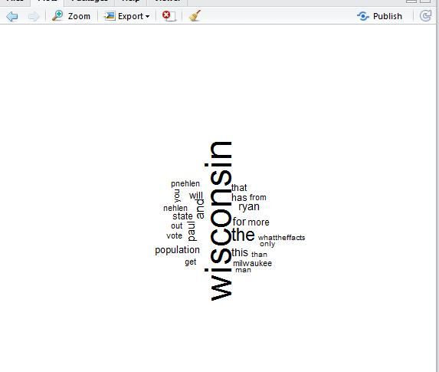

# Tableau Map Visualization

### Are there any states in the dataset that have lost money?

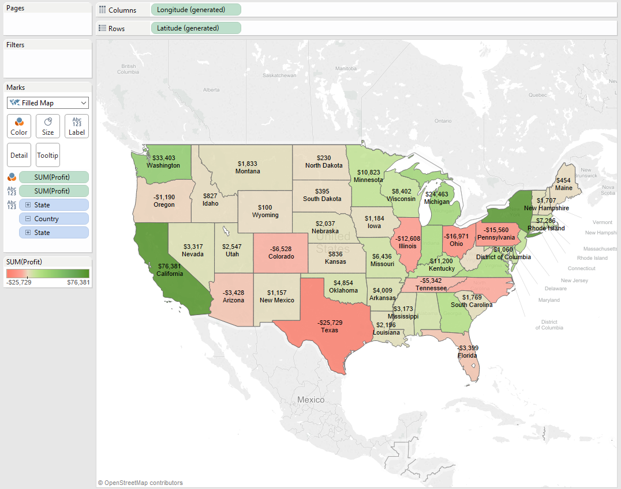

### Which state has the highest total sales in the dataset?

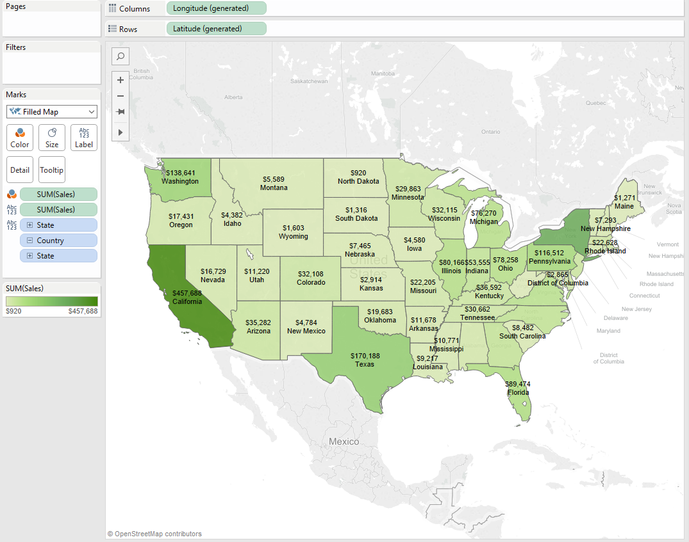

# Visualization in R Studio

### Histogram of carats using ggplot2

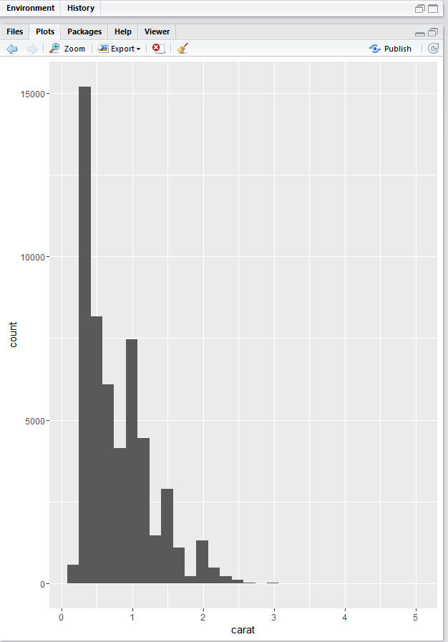

When creating a histogram of carats, we can see that a majority of the diamonds are between 0 and 1 carats, and as the value of carat goes up there are less number of diamonds . There are also some peaks at what look like to be specific intervals (i.e. 1, 1.5, 2, 3)

### Scatterplot mapping carats (x) and price (y) using ggplot2, Use color aesthetic argument.

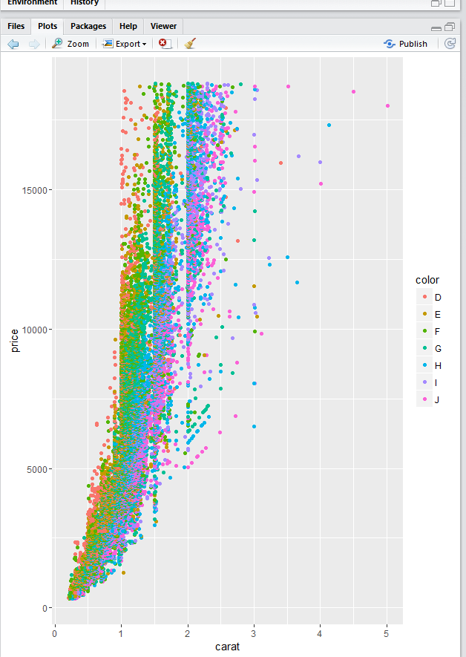

As carat increases price also increases. Color level will also increase or decrease the slope of increase.

### Boxplot of diamond carats using ggplot2

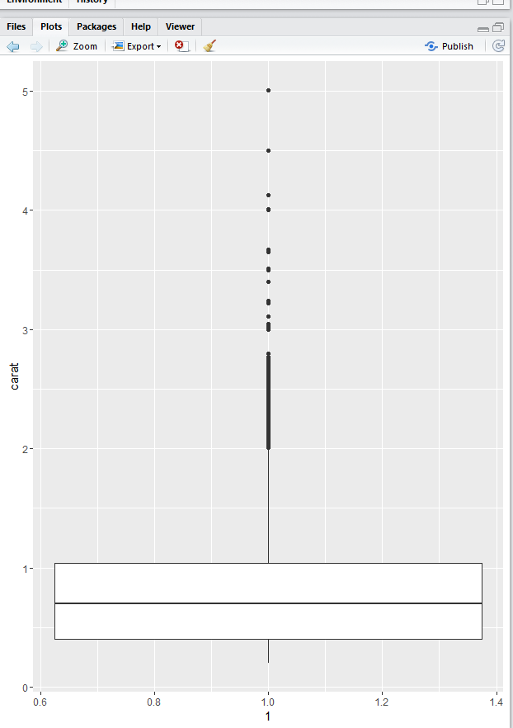

The inner quartile range is a little less than .5 carats to a little more than 1 carat meaning that half of the diamonds fit within that range. There a few diamonds that are considered outliers that sit above the upper whisker at about 2 carats.

### A violin plot of diamond carats by cut using ggplot2

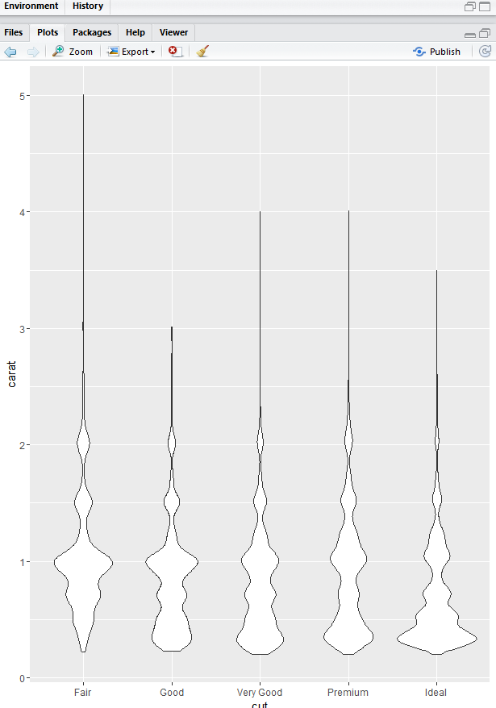

We can still see that a lot of the diamonds fit on the .5 interval between.5 and 2 carats. But we can see depending on the cut the carat amount is likely different, so for an Ideal cut diamond you are more likely to see smaller carats than compared to a Fair cut.

### Using summary() and head() functions, provide an overview of the dataset.

